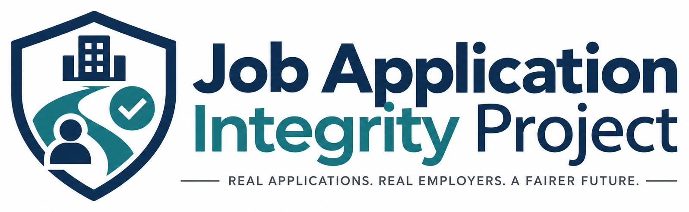

MEDIA BACKGROUNDER
Job Application Integrity Project (JAIP)
JAIP is a free public-service initiative working to improve transparency, accountability and trust in the online employment marketplace.

About JAIP
The Job Application Integrity Project works to improve transparency, accountability and trust in the online employment marketplace. JAIP supports responsible job distribution and the important role played by authorized, reputable employers, recruiters, job boards, advertising partners, search engines, aggregators and recruiting technology providers.
JAIP focuses on application integrity: whether job seekers can understand who is behind an opportunity, where their information is going, and whether an application represented as going to a particular employer actually reaches that employer or an authorized recruiting representative.

Why JAIP Was Founded
JAIP was founded by Paul Cornell after more than 35 years in recruiting and thousands of interviews with job seekers. His experience has provided a firsthand view of the emotional and financial challenges people can face while looking for work, along with the growing challenges employers face protecting their brands, controlling application paths and ensuring qualified candidates actually reach them.
JAIP is not anti-job-board or anti-recruiter. The Project believes authorized, reputable third parties can add substantial value. The concern is what happens when authorization, transparency, accountability or verifiable delivery disappear from the process.

Founder

Paul Cornell - Founder
Paul Cornell has worked in recruiting for more than 35 years and has interviewed thousands of job seekers while working with employers across a wide range of industries. He founded JAIP after seeing a growing number of confusing online application experiences, employer impersonation, unauthorized job distribution, misleading recruiting activity and uncertainty about where applicant information ultimately goes.

Current Initiatives
- Verified Application Path Standard - a proposed framework addressing employer identity, application-recipient disclosure, verified delivery, current job status, source transparency and employer control.
- Public job-seeker and employer resources - free educational guidance on application paths, warning signs and responsible job distribution.
- Government reporting resources - guidance for job scams, employer impersonation, identity theft, discrimination, background-screening issues and related concerns.
- Founding Advisory Council - a multidisciplinary advisory group being formed to challenge assumptions and strengthen JAIP methodology and governance.
- Application-path research - evidence-based study of how online jobs move from authoritative employer postings through discovery channels to final application destinations.

Topics for Media and Research Interviews
- Online job application transparency and where Apply actually goes
- Employer impersonation, fake recruiters and brand misuse
- Responsible third-party job distribution
- Candidate trust, frustration and the emotional cost of job seeking
- Unauthorized job distribution and employer control
- Application-path research and evidence standards
- Future verification principles for application paths

Press-Ready Boilerplate
The Job Application Integrity Project is a free public-service initiative working to improve transparency, accountability and trust in the online employment marketplace. JAIP supports responsible job distribution and the important role played by authorized, reputable employers, recruiters, job boards, advertising partners, search engines, aggregators and recruiting technology providers. The Project is developing standards, research, educational resources and reporting tools designed to help ensure that job seekers can understand who is behind an opportunity, where their information is going and whether their application reaches the employer or authorized recruiting representative they intended to reach.

Media Asset Use
Approved JAIP logos and marks may be used in factual editorial coverage of the Project. Use of JAIP materials must not imply endorsement, certification or verification of an organization, product, service or application path unless JAIP has explicitly published that designation.
Do not alter the logo proportions, recolor the logo, remove elements from the horizontal logo, or place the mark in a way that suggests sponsorship or endorsement.

Current Organizational Status
JAIP is currently a free public-service initiative developing its long-term organizational, governance and funding structure. JAIP is not currently representing itself as an IRS-recognized 501(c)(3) organization, and the current public materials do not represent contributions as tax-deductible charitable donations.

Media Contact
Paul Cornell, Founder
Job Application Integrity Project
Website: jobapplicationintegrity.org
A dedicated public media email and phone number will be added when JAIP formalizes its external communications process.

Included in the JAIP Media Kit
- Horizontal JAIP logo (PNG)
- JAIP shield mark (PNG)
- Full project logo (PNG)
- JAIP Media Backgrounder (PDF and DOCX)
- Founder Bio (plain text)
- JAIP Boilerplate (plain text)
- Media Asset Usage Guidelines (plain text)
Founder photography is not yet included. JAIP plans to add an approved professional Founder headshot when available.

